### Practical File

### Of

### Fundamentals of C Programming

### 22CS002

#### Submitted

#### in partial fulfillment for the award of the degree of

## BACHELEOR OF ENGINEERING

***in***

COMPUTER SCIENCE & ENGINEERING



**CHITKARA UNIVERSITY**

**CHANDIGARH-PATIALA NATIONAL HIGHWAY**

**RAJPURA (PATIALA) PUNJAB-140401 (INDIA)**

##### May, 2024

##### **Submitted To: Submitted By:**

##### Dr. Gaganpreet Kaur Kashish

##### Associate Professor 2310990710

##### Chitkara University, Punjab 2nd Semester

##### 2023 Batch

INDEX

|  |  |  |
| --- | --- | --- |
| **Sr No.** | **Practical Name** | **Teacher’s Signature** |
| 1 | Write a Program to show the use to input (Scanf)/ output (Printf) statements and block structure of C program by highlighting the features of “stdio.h”. |  |
| 2 | Write a program to add two numbers and display the sum |  |
| 3 | Write a program to calculate the area and the circumference of a circle by using radius as the input provided by the user |  |
| 4 | Write a Program to perform addition, subtraction, division and multiplication of two numbers given as input by the user |  |
| 5 | Write a program to evaluate each of the following equations  (i)V = u + at (ii) S = ut + 1/2at^2 (iii) T = 2*a + √b + 9c (iv) H = √ b ^ 2 + p^2 |  |
| 6 | Write a program to swap two variables:   1. By using temporary variable. 2. Without using temporary variable |  |
| 7 | Write a program to find the greatest among the numbers using:   * Conditional Operator * If-Else statement |  |
| 8 | Write the following programs using switch case statement :   * To check that an input alphabet is vowel or consonant * To check whether a number is positive, negative or zero |  |
|  |  |  |
|  |  |  |
|  |  |  |
|  |  |  |
|  |  |  |

PROGRAM1

Write a program to show the use to input (Scanf) / output (Printf) statements and block structure of C-program by highlighting the features of “ stdio.h”

Solution:

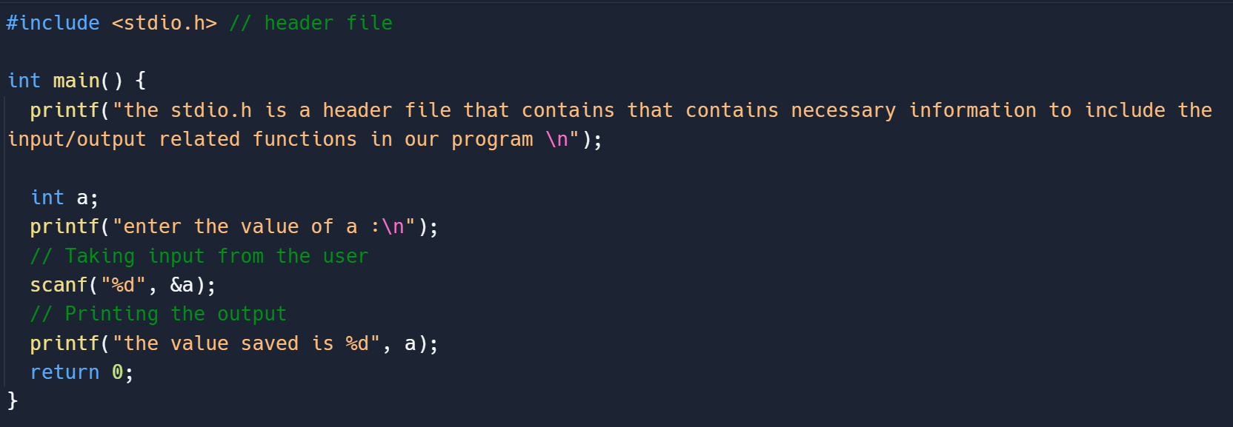

Output:



PROGRAM 2

Write a Program to add two numbers and display the sum.

Solution:

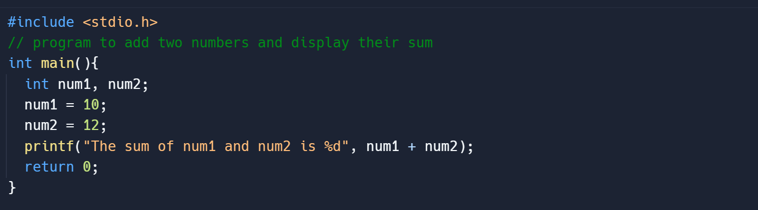

Output:



PROGRAM 3

Write a program to Calculate the area and circumference of a circle by using radius as the input provided by the user

Solution:

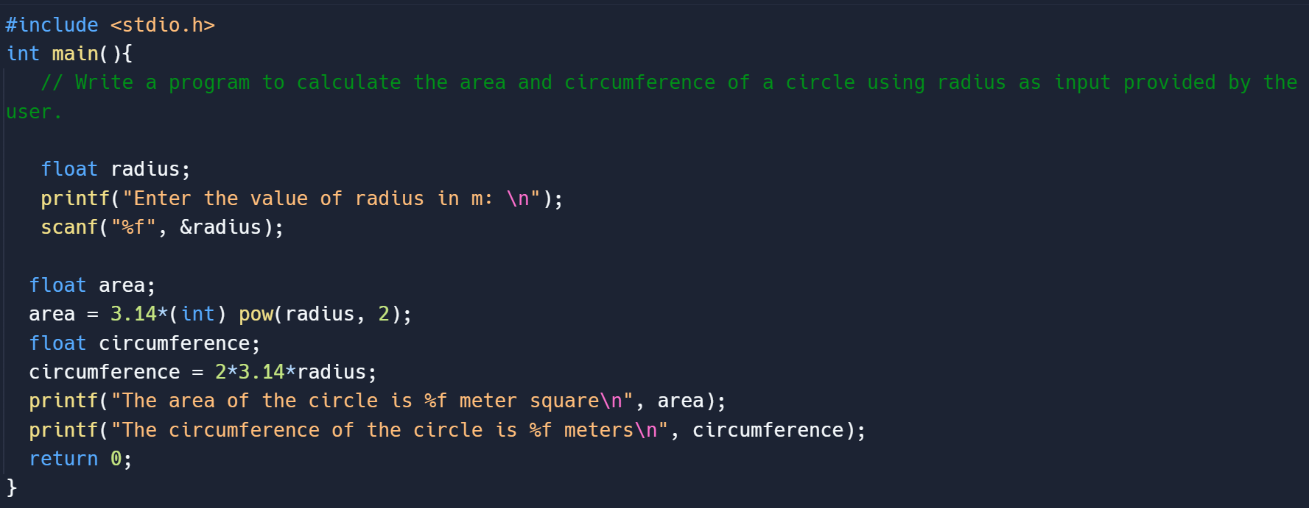

Output:

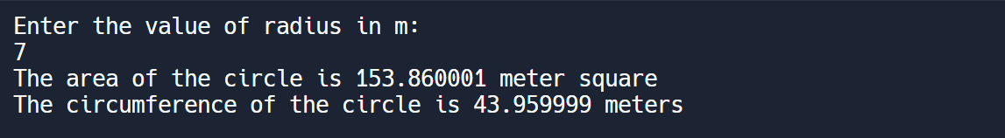

PROGRAM 4

Write a program to perform addition, subtraction, division and multiplication of two numbers given as input by the user

Solution:

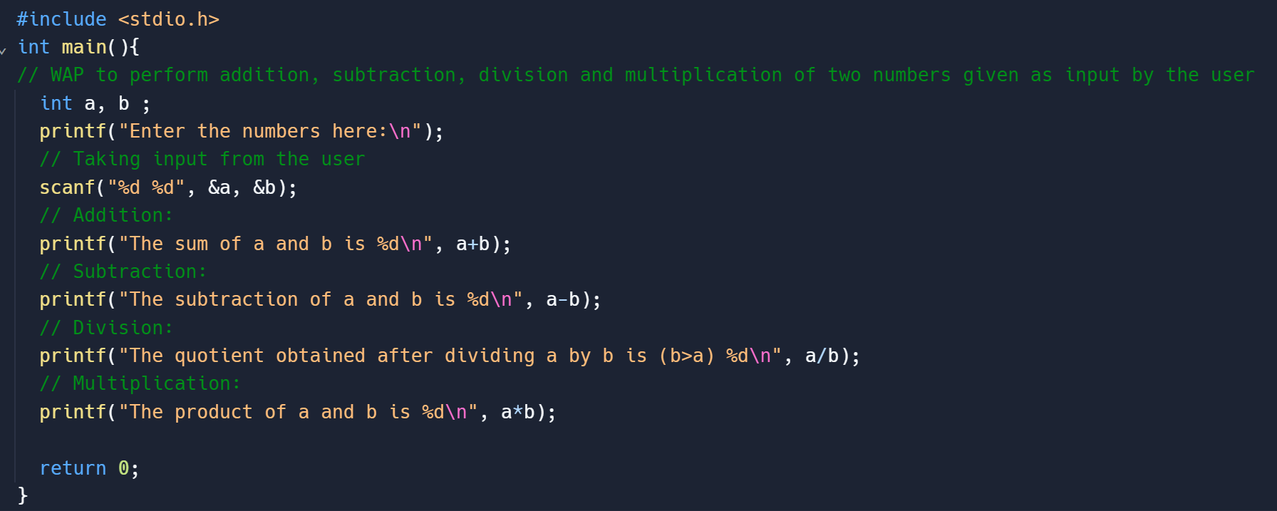

Output:

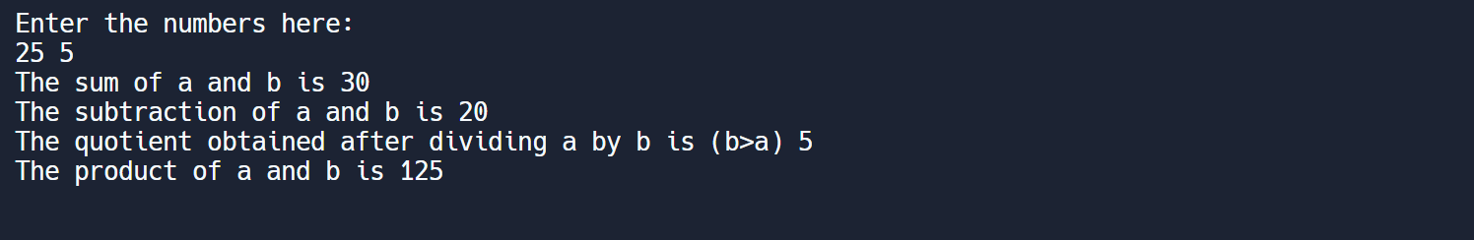

PROGRAM 5

Write a program to evaluate each of the following equations

1. V = u + at
2. S = ut + ½ at^2
3. T = 2a + √b + 9c
4. H = (√b)^2 + p^2

Solution:

1. V = u + at

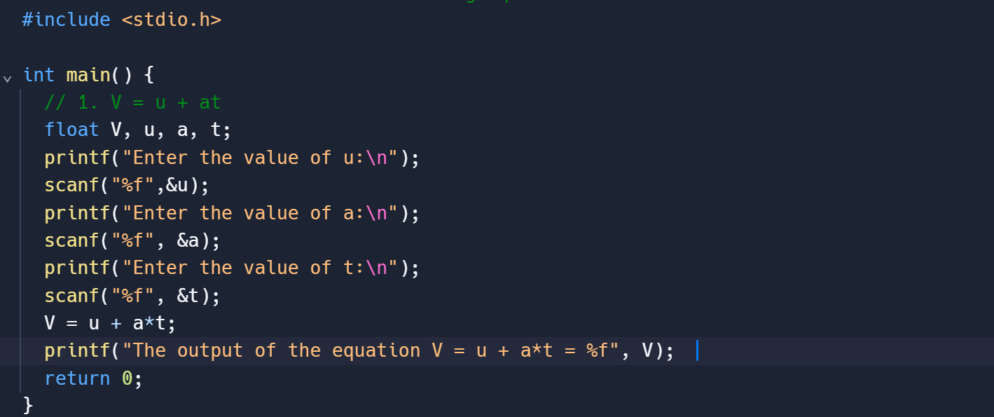

Output:

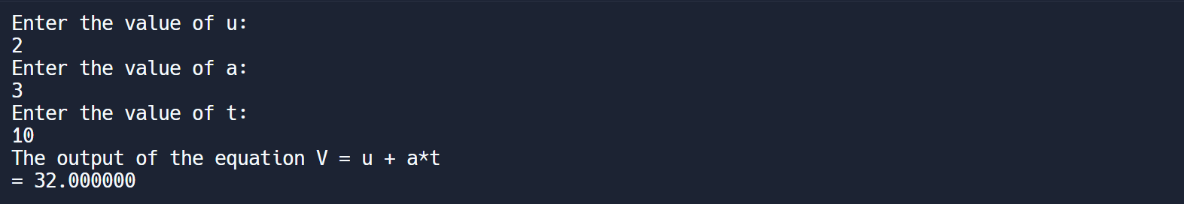

1. S = ut + ½ at^2

Solution:

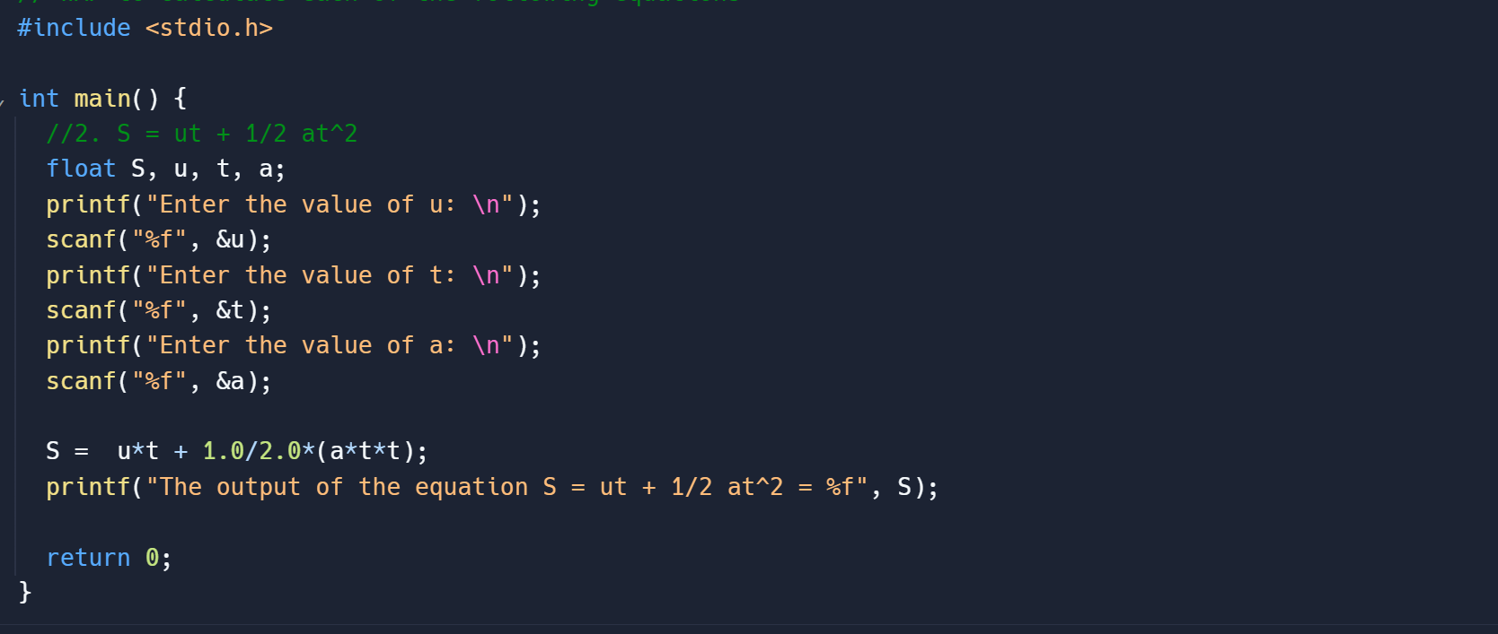

Output:

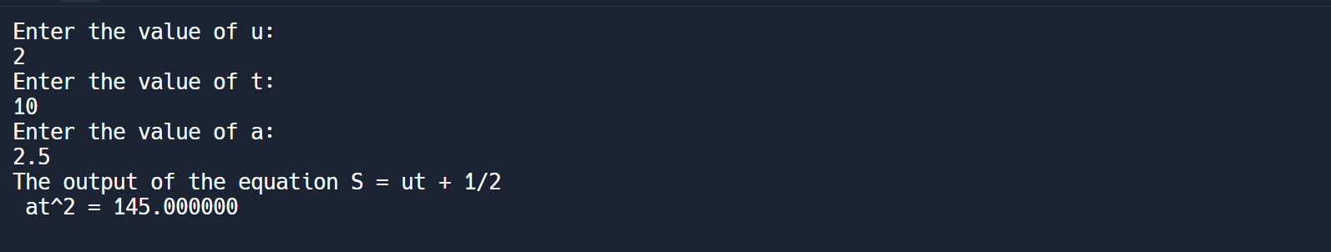

1. T = 2a + √b + 9c

Solution:

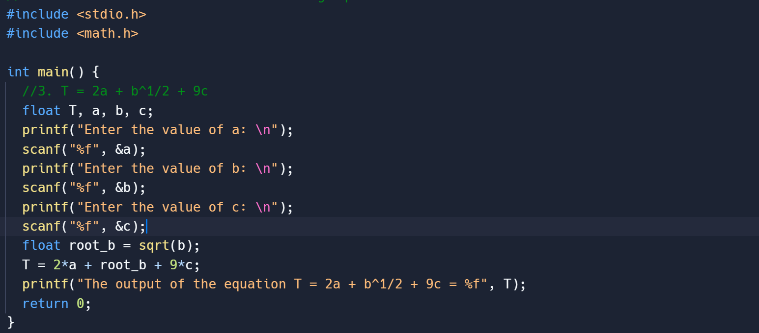

Output:

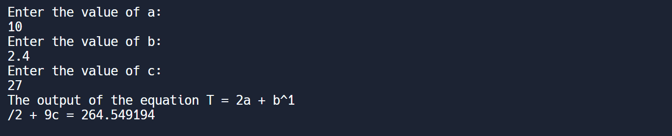

1. H =(√b)^2 + p^2

Solution:

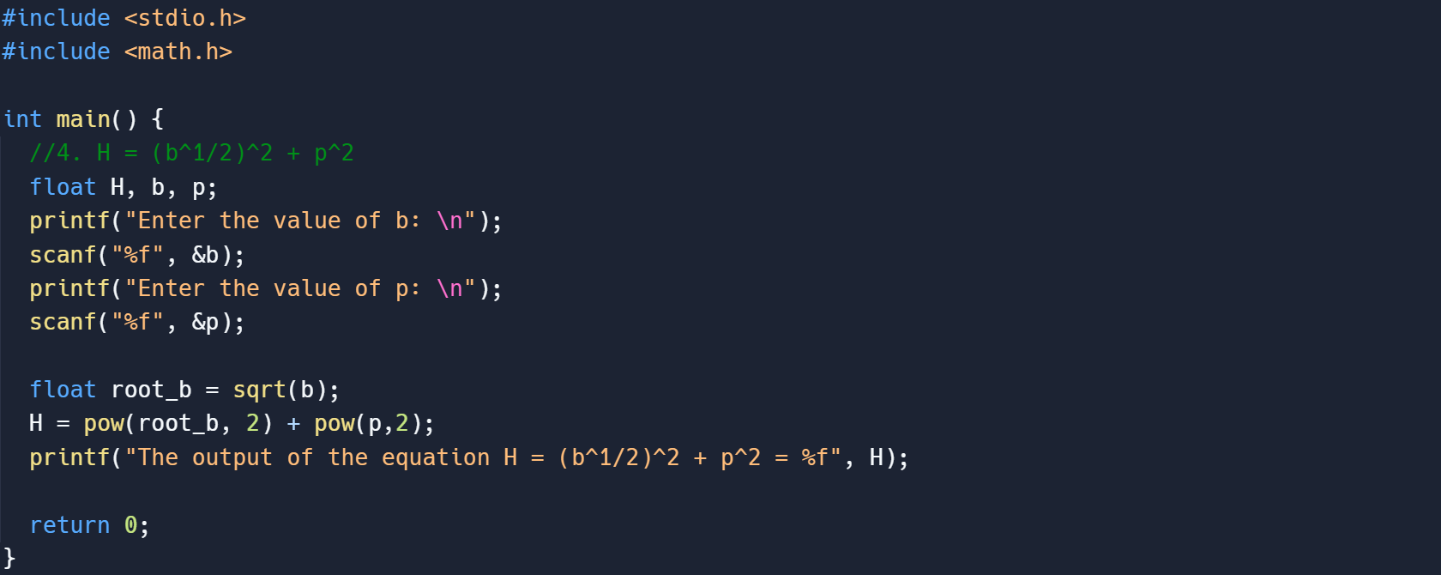

Output:

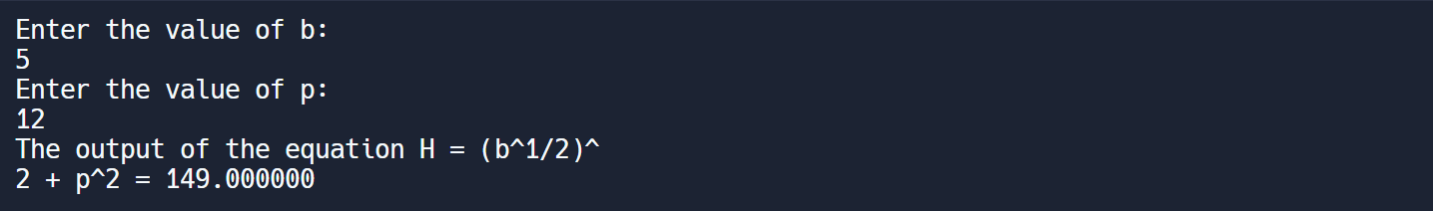

PROGRAM 6

Write a program to swap two variables

1. By using temporary variable

Solution:

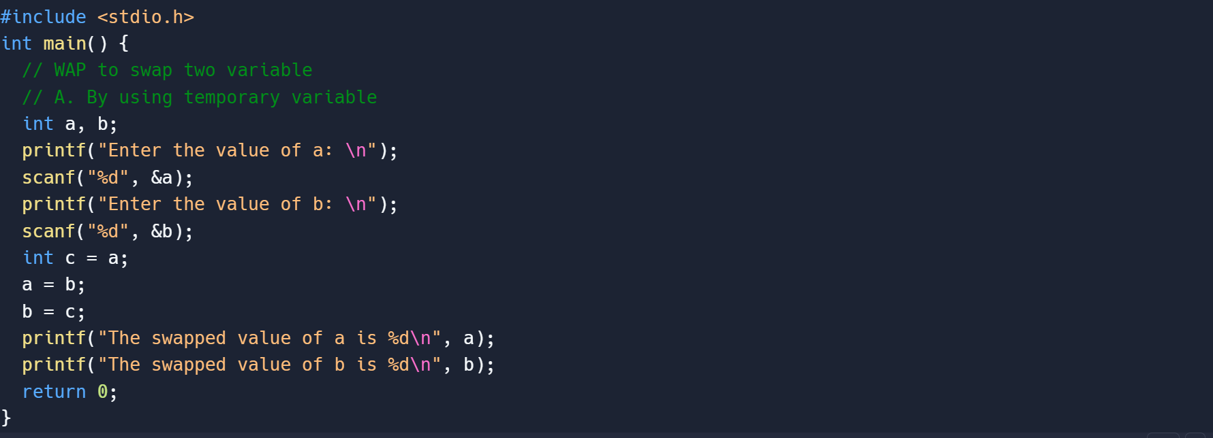

Output:

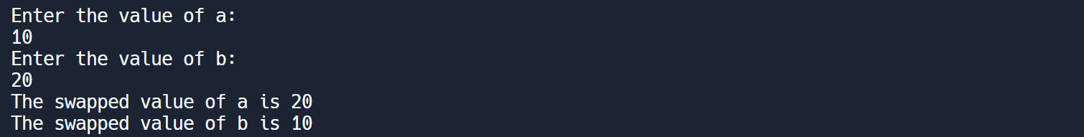

1. Without using Temporary Variable

Solution:

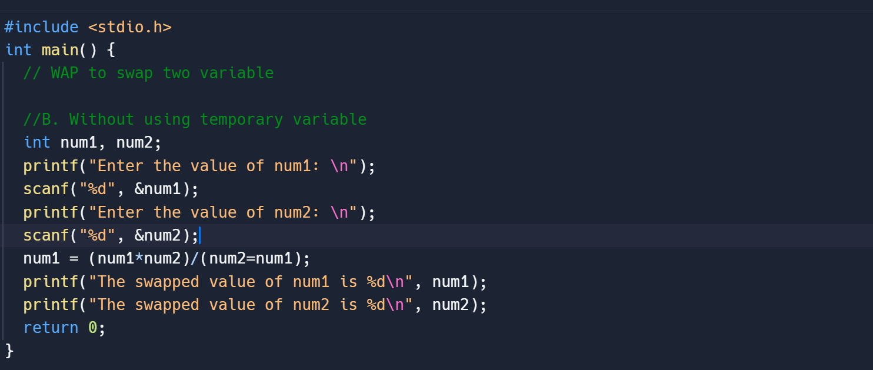

Output:

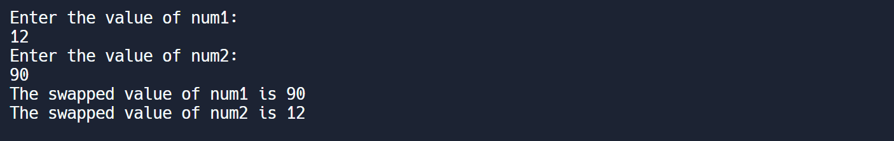

PROGRAM 7

Write a program to find the greatest among three numbers using:

1. Conditional Operator

Solution:

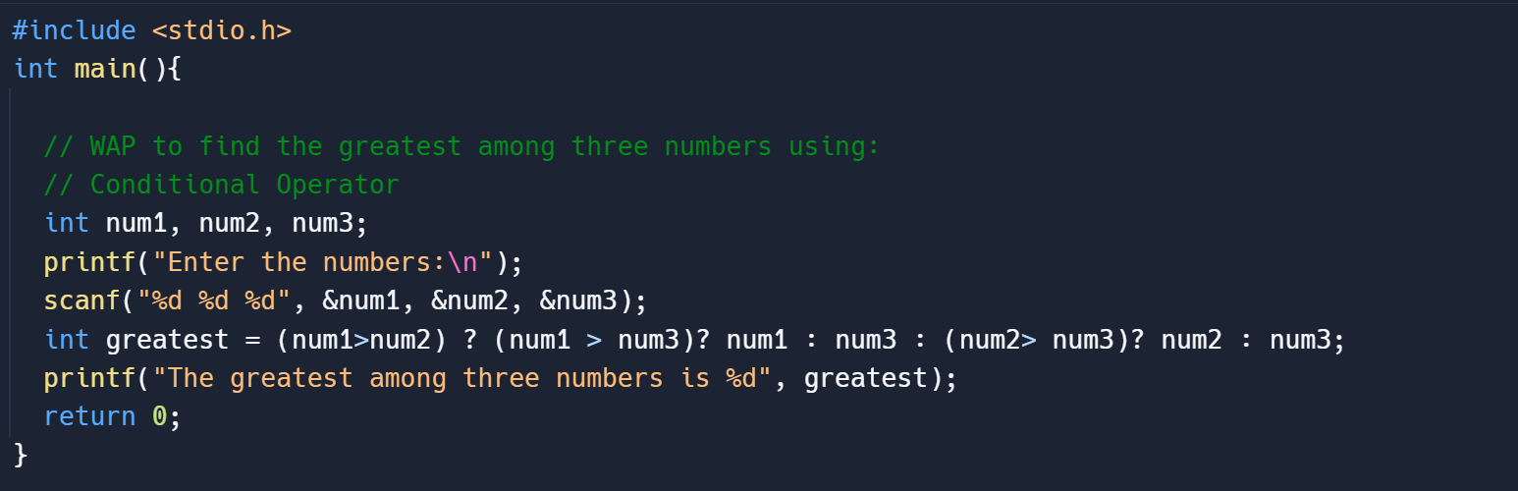

Output:



1. If-Else Statement

Solution:

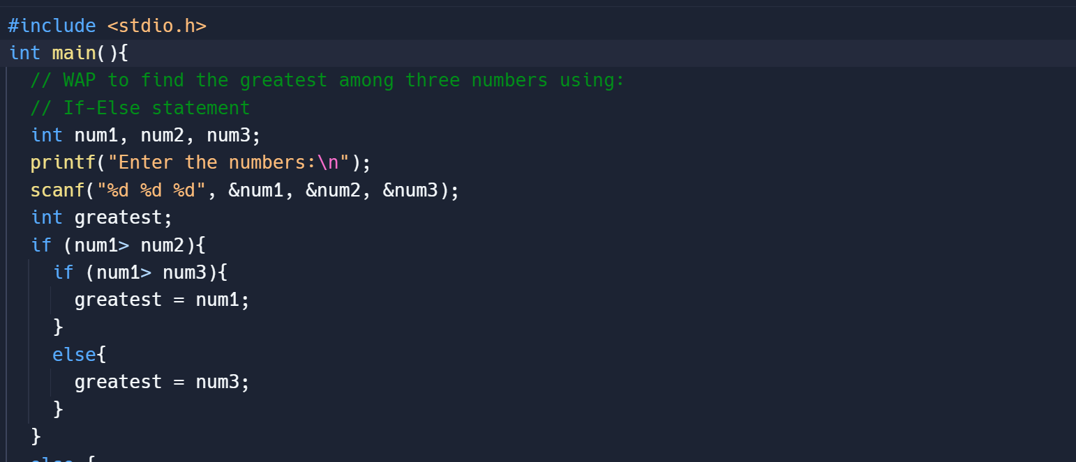

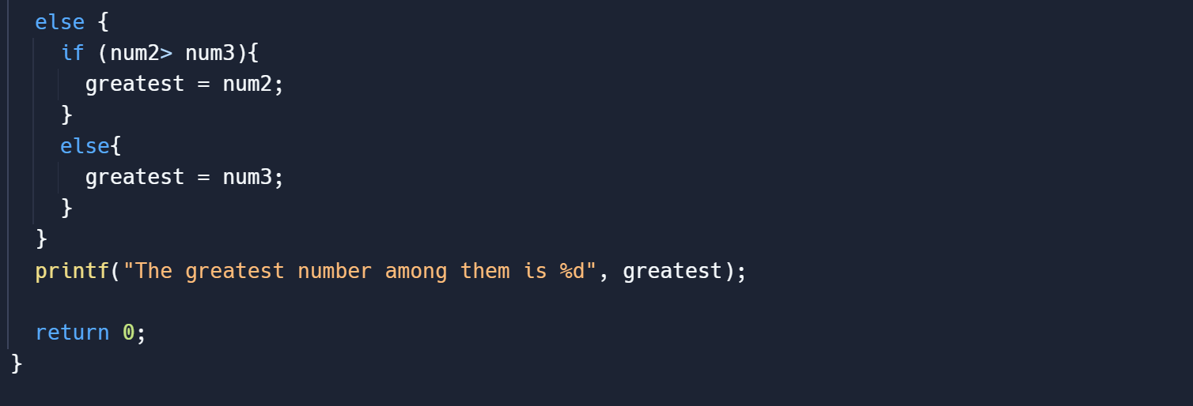

Output:

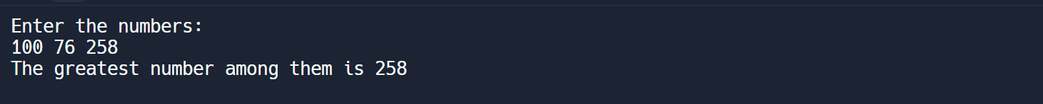

PROGRAM 8

Write the following programs using switch case statement

1. To check that an input alphabet is vowel or consonant

Solution:

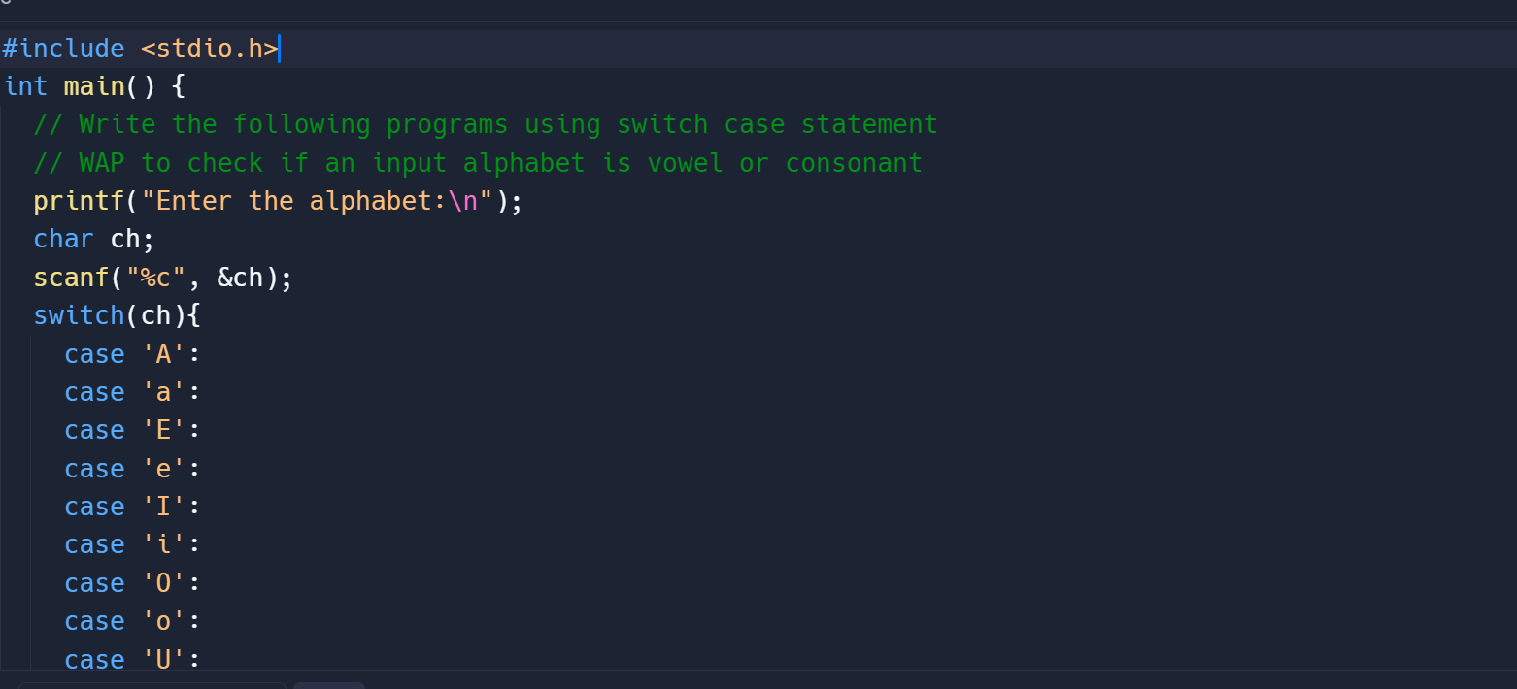

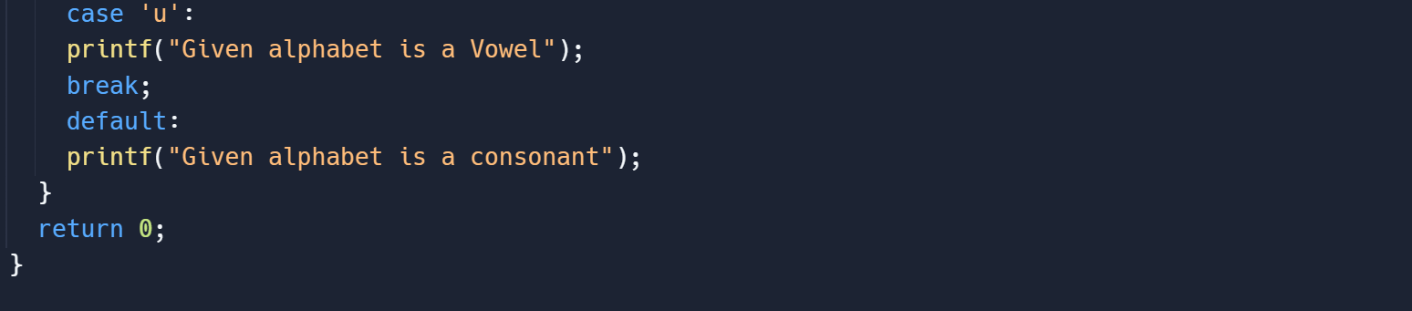

Output:

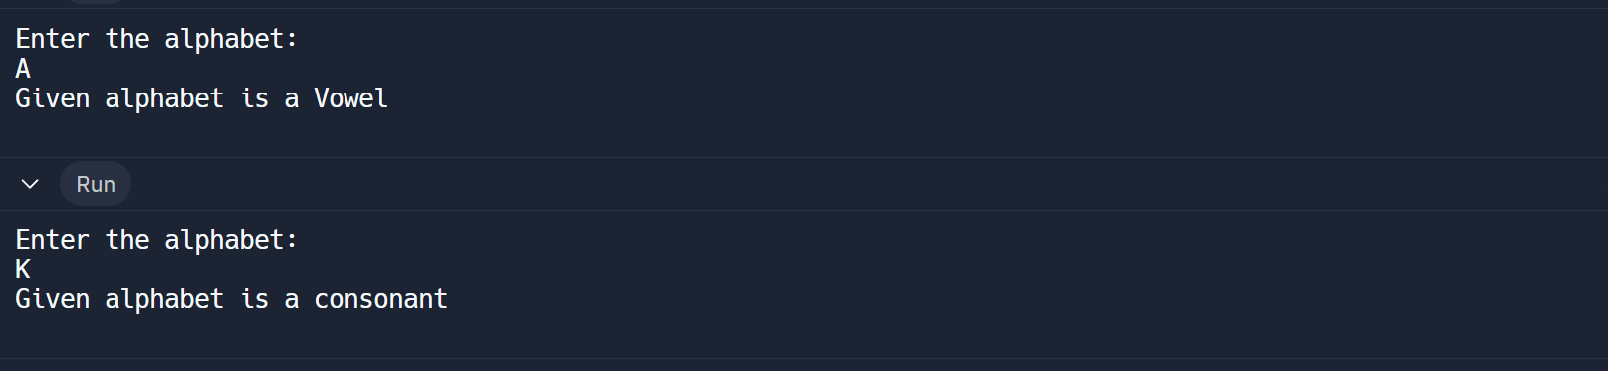

1. To check if an input number is positive, negative or zero

Solution:

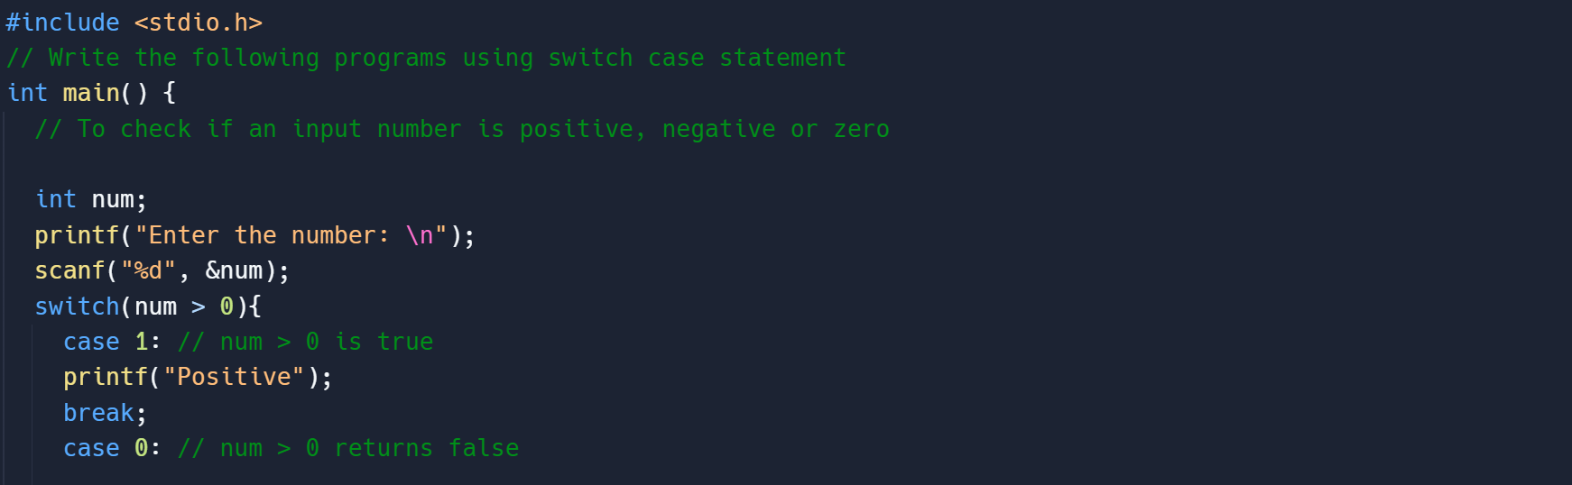

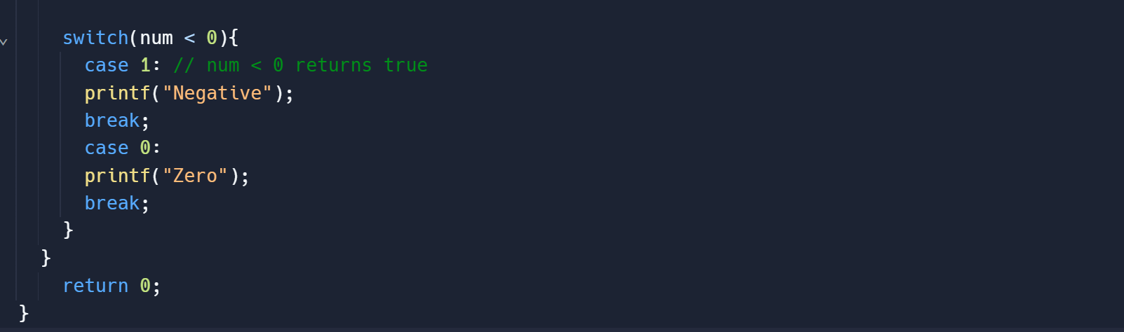

Output:

